**Step-by-step procedure on how to resolve the following incidents:**

Cant find booking in CRR

* Delete data in crr\_booking\_summary by booking\_id

Issue Description: **CRR for backtrack**

Issue Log#: u190802-07684

E.G

CRR# : A11512019-01084

Remmitance details id:

310427

310433

310452

310463

310464

310466

Related Tables:

crr\_remittance\_hdr

crr\_remittance\_dtls

crr\_payments

**Steps**:

1.Get the crr\_remittance\_hdr

**Select** id,crr\_status **from** crr\_remittance\_hdr **where**

control\_no = 'A11512019-01084'

After getting the result, change the crr\_status to “N” – this is Pending

2.Get the remittance details

**Select** id,crr\_id,remittance\_status **from** crr\_remittance\_dtls **where** id **in** (

310427,

310433,

310452,

310463,

310464,

310466

);

And update the remittance\_status field to “F” – For Acceptance

3.Get the crr payments

**SELECT** id,crr\_id,**status**,remit **FROM** crr\_payments **WHERE** remittance\_id **IN** (

310427,

310433,

310452,

310463,

310464,

310466

);

Update the two fields status and remit to ‘N’ – Pending

**Request to add Captain accounts in  CRR module**

**Issue Logs:**

u190723-07329

u190715-07051

**E.G**

CRR - Request to add below accounts to A1189 - Captain Account

C5082

B4185

C5119

A1147

C5080

J1202

**Related Table:**

crr\_account\_matrix

**Steps:**

1.Get the captain account

**SELECT** id,dstbr\_code,captain\_tag,others **FROM** crr\_account\_matrix

**WHERE** dstbr\_code = 'A1189'

2.Append the accounts in the others field.

account_matrix.PNG

**Request to change status of CRR transaction**

Issue : Incorrect delivery date of booking transaction

Account : A1130

CRR# : A11302019-00749

Collection ID : 259499

Remittance ID : 304134

u190722-07264

u190425-03597

Related Tables:

crr\_remittance\_hdr

crr\_collections

crr\_remittance\_dtls

crr\_payments

**Steps:**

1.Get the remittance header

**SELECT** id,crr\_status **FROM** crr\_remittance\_hdr **WHERE** control\_no = 'A11302019-00749'

And change the crr\_status field to ‘N’ – Pending

2.Get the crr collection

**SELECT** id,crr\_id,**status** **FROM** crr\_collections **WHERE** id = 259499

Change the status to ‘N’ – Pending

3.Get the remittance details

**SELECT** id,crr\_id,remittance\_status **FROM** crr\_remittance\_dtls

**WHERE** id = 304134

Update the remittance\_status to ‘F’ – For Acceptance

4.Get the payments

**SELECT** id,crr\_id,**status**,remit **FROM** crr\_payments

**WHERE** remittance\_id = 304134

Update the status and remit field to ‘N’

**No Email Notification from the Buyer (Genpro) upon Placing an Order (Order Ref:  DE-MP-19-1059).**

u190318-01986

-This is for monitoring.

**Please assist to change the email default to maryjoy.galiza@rebmain.com. for the following customers:**

u190320-02141

**Steps:**

1.Access the Customer Portal

<https://store.rebisco.com.ph/customerPortal/admin>

2.Go to the Navbar>Maintenance>Customer File

3.Search in the table using the customer name or cust\_code, when you get the result, click the edit button in the right side of the table row.

4.You will be redirected to the customer profile page, then you can add the email address and update the details of the customer.

**Kindly assist on searching for missing order on ECP, inquired by Ms. Mary Joy Galiza.**

Reference Number: DE-US-19-1043

u190430-03833

-No action

**FOR CUSTOMER PRICE BUILDUP AND UPDATE**

**FOR ACTIVATION OF NEW CUSTOMER**

**FOR UPDATING PRODUC**

**Issue Logs:**

u190426-03652

u190717-07156

**Steps:**

1.Get the masterdata file from Ma’am Kathleen Mijares

data.PNG

2.Extract the master data and get the following folder (DISTRIBUTOR, EXPORT\_PRICING,PRODUCT\_ECP)

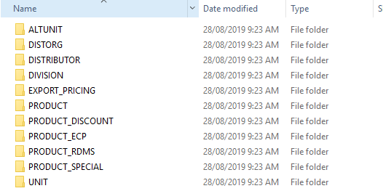

3.Access each folders and get the text file.

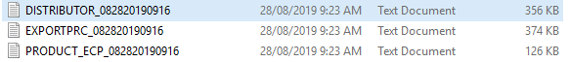

4.Drop all the text files in the ECP production server

**PATH** : /var/www/html/customerPortal/app/storage/masterfiles

There is a running cron job that will get the data from the text files and it will be save in the ECP database.

5.When the process is done, the text files extension will be change to .done

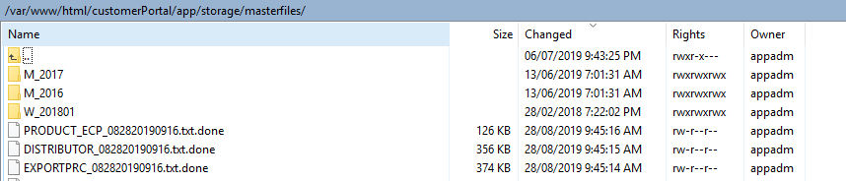

**Hindi ma confirm or ma approve ang proforma invoice**

transaction number: DEHK191072

customer: premium hongkong foods

u190314-01813

**Related Table:**

Proforma

**Steps:**

1.Get the proforma

**SELECT** id,order\_ref\_no,proforma\_signed\_file **FROM** proforma **WHERE** order\_ref\_no = 'DE-US-19-1263'

proforma.PNG

Remove the last string in the proforma\_signed\_file that look like this “|” .

**Dear Guill,**

Good afternoon. I am emailing to request your kind assistance to update the following info of Rebisco Cracker Sandwiches with their corresponding HAWA codes (See attached file for your reference) in our ECP:

1. Product Description

2. Packing Scheme

3. CBM per ctn

Let me know once you're done.

Thank you!

All the best,  
  
Drew Sarmiento

**-This is for master data update**